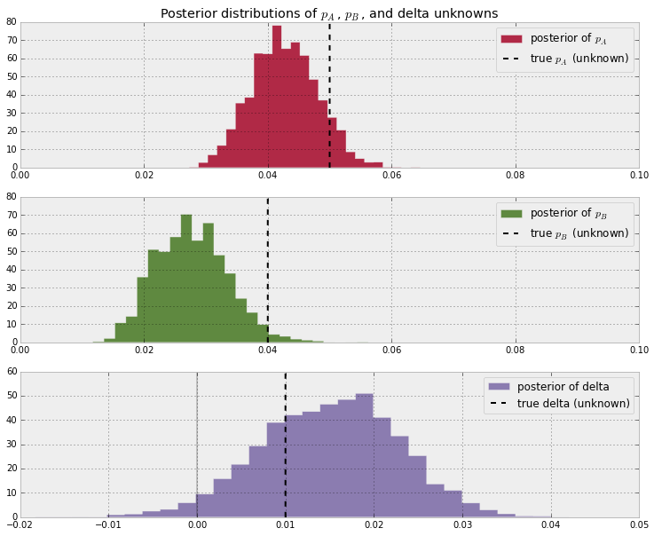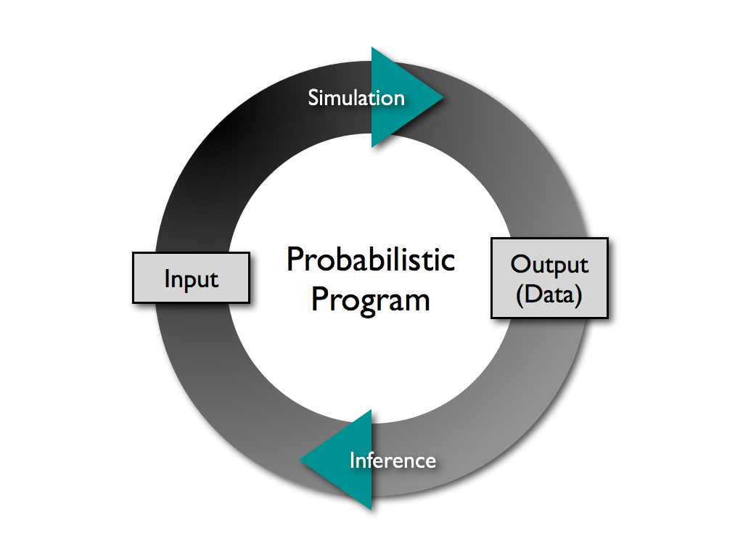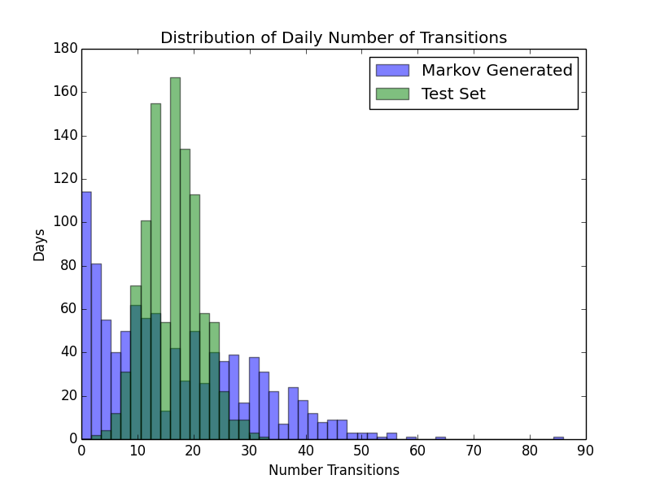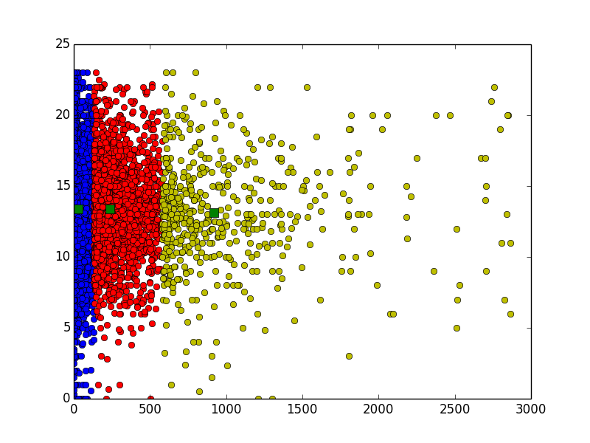

* UMass Email log files
* >7000 users over4 months period
* 10 Million entries of …

User Date Time Start

Time End IP

Device

- Sessions

MIT SECURE

Cambridge Station

New England Networks

Networks

AT&T 4G LTE

Boston AT&T Station

US Eastern

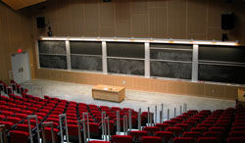

### Topological ≠ Physical Mobility

Goal:

- Model and predict topological mobility of wireless users

Motivations:

- Improved models and simulations of users mobile behaviors

- Evaluation of new Internet scale network architectures

- Exploration of new modeling techniques and their application to networking challenges

## Identify different types of users

## Predict length of sessions

## Model frequency of transition between networks

**Goal & Motivations**

Support

NSF Grant No. 1413973, NeTS: Large: Collaborative Research: Location-Independent Networks: Evaluation Strategies & Studies

Major Contributions

1. Built and evaluated new models for network topological mobility.
2. Contribution to understanding of how network mobility affects new network design
3. Use and demonstration of suite of tools for broad exploration possibility

A suite of machine learning tools were used in this networks problem due to the size of the dataset

**Results**

**Datasets**

|  |  |  |
| --- | --- | --- |
| Technique | Toolkit | Usage |
| Probabilistic  Programming | PYMC3 | Fast Inference |
| Regression | Sklearn | Find optimal duration |
| Neural Net | Tensorflow | Classify sessions |
| KMeans clustering | Scipy | Identify user types |
| Data processing | Pandas | Disecting data |

**Techniques**

## **Predict Users Mobility in Networks - Shidan Xu - ANA Group**

Lorem Ipsum Dolor